C:\Users\kemarinucci\AppData\Local\Microsoft\Windows\Temporary Internet Files\Content.IE5\SBTW2F8R\MC900055182[1].wmfName: Quang Huynh

**Map of the Human Heart**: An Interactive Exploration

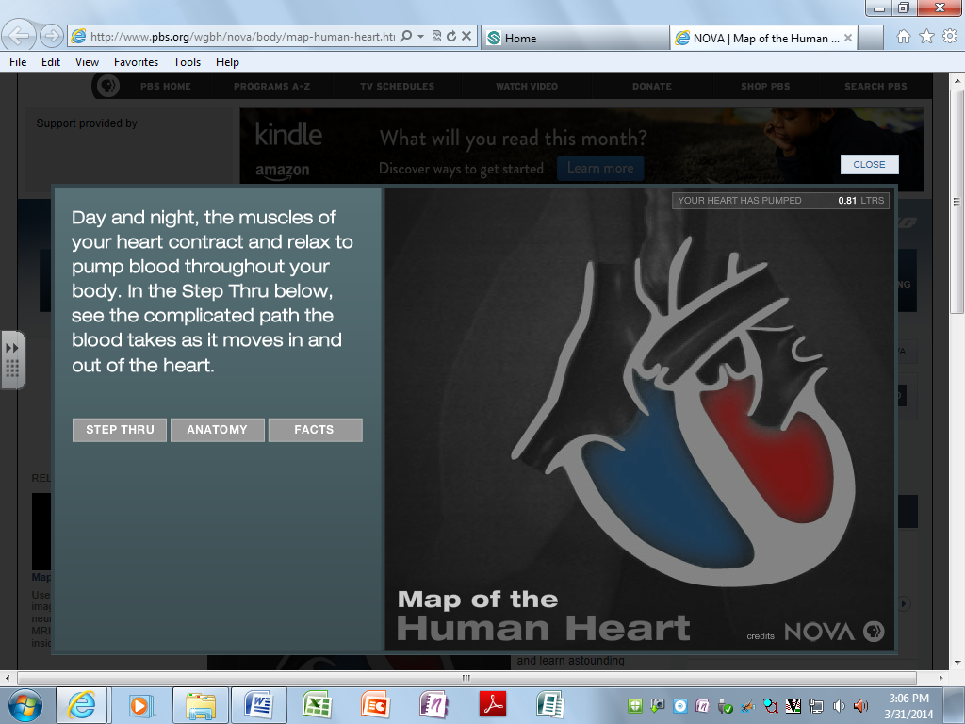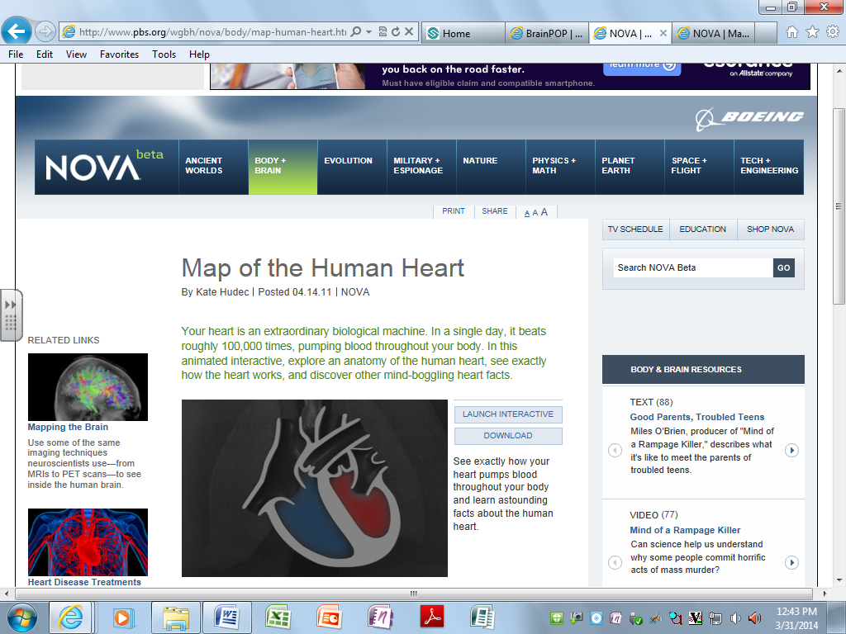Directions: Visit the following website: <http://www.pbs.org/wgbh/nova/body/map-human-heart.html> and click on the box that says . Click on TRACK to track the number of liters of blood your heart pumps while you are working on this activity.

Click to begin mapping the pathway of blood through the heart. Push pause so you can go at your own pace through each step. Label the parts AND describe what happens at each step.

STEP 1: Deoxygenated goes into the right atrium from the body

STEP 2: The blood flows through the right atrium to the right ventricle.

STEP 6: The left ventricle pumps the oxygenated blood to back to the body

STEP 5: Blood flows through the left atrium to the left ventricle

STEP 4: The oxygenated blood goes back to the heart and enters the left atrium.

STEP 3: The blood flows from the right ventricle to the lungs. The blood gets oxygenated and removes waste

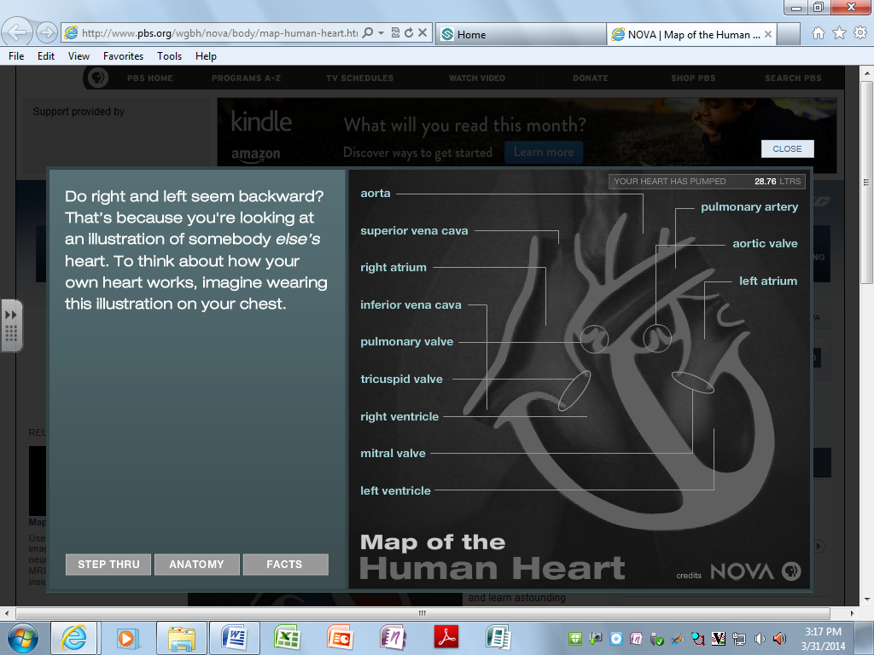Click on to explain why the right and left seem backward when labeling your diagram: The heart is an illustration and the sides are switched around because you would be looking at a heart. If you were “wearing” the heart, then the sides would be correct.

Click on to learn some interesting facts about the circulatory system and the heart.

1. **Where is your heart actually located?** The heart is located in the center of the chest above the lungs.
2. **About how big is an adult heart?** About two fists
3. **How do the muscles in the heart compare to the leg muscles in terms of how hard they work at rest?** The heart works twice as hard than the leg muscles of somebody running.
4. **How big is the aorta compared to the capillaries?** The aorta is almost the size of a garden hose. Capillaries would be the size of a human hair.
5. **What should YOUR approximate resting pulse be?** The approximate resting pulse should be 90-120 beats per minute as a child. But as an adult, the average pulse is 72 beats per minute.
6. **How much blood does your body have, and how often does it circulate through your body?** Your body has 5.6 liters of blood and travels 12,000 miles per day.
7. **How often does your heart beat in one day?** In one day, the heart beats 100,000 times.
8. **What causes the “LUB DUB” sound in your heart as it beats?** The LUB DUB noise is made by the values of the heart as they open and close.

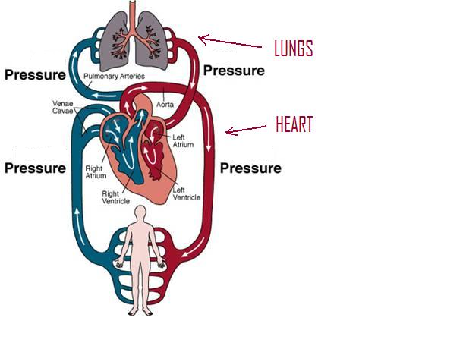

Try to Identify:



Label the lines as either

**high** pressure or **low**

pressure.



Fill in the boxes as

either **oxygenated** blood

or **deoxygenated** blood

Oxygenated Blood

Deoxygenated Blood